**Name: Qazi Yahya**

**Program: BCS**

**Semester: 01**

­­­

Project Description:

My website is about a fictional software development company called ‘All-Devs’. The website has three pages Home Page, Testimonials (Customer Reviews) Page and a Contact Page.

Home Page:

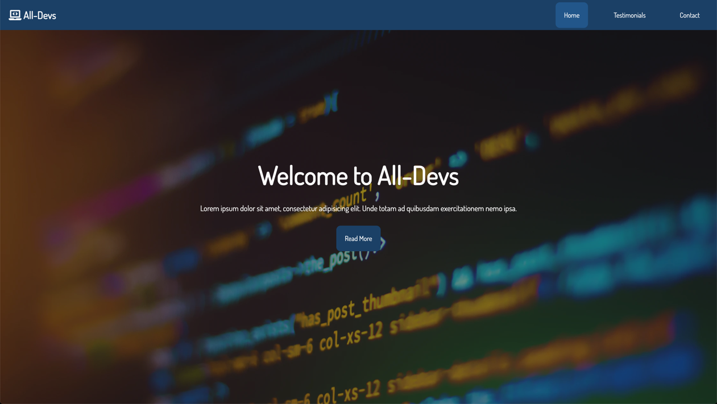The Home Page has a showcase at the beginning with a background image, a line of text and a read more button. A screenshot of the showcase is as follows:

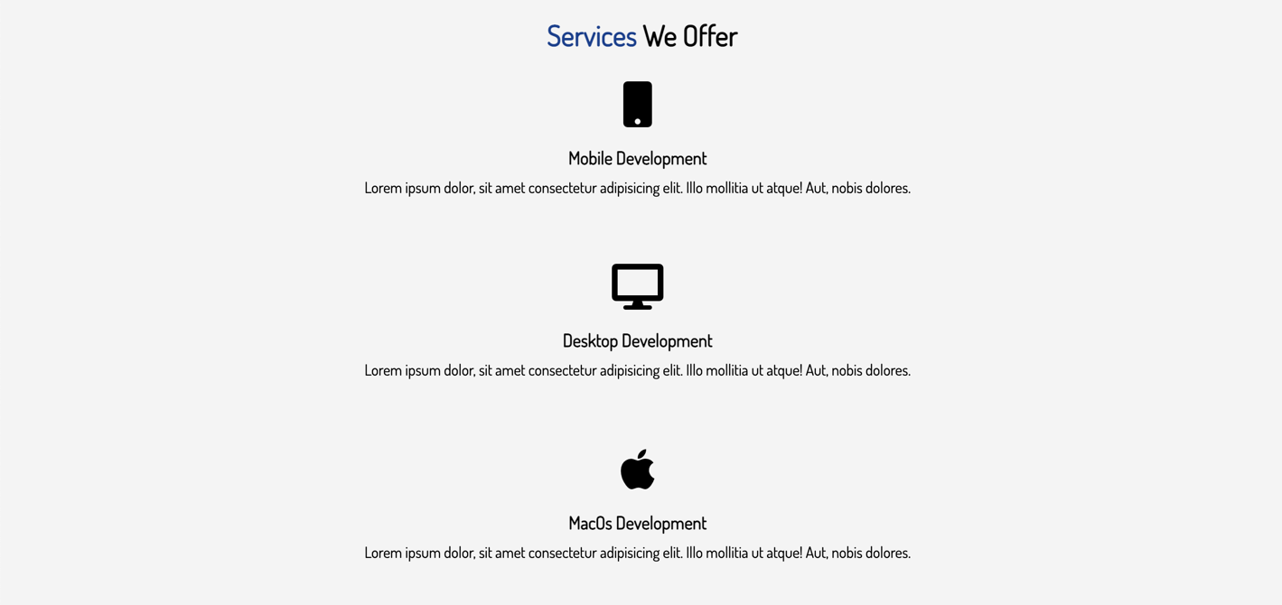After the showcase there is a description of the services this company offers. A screenshot of that section of the webpage is as follows:

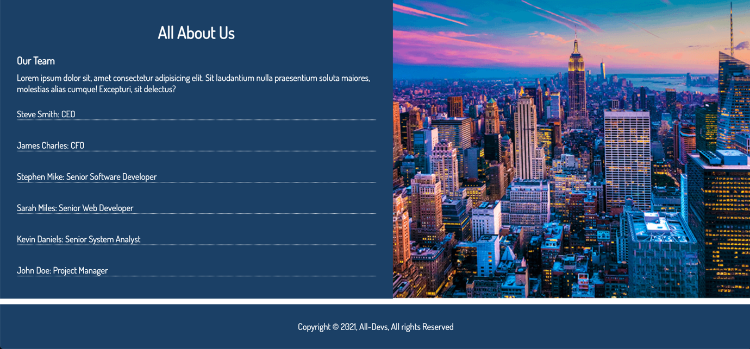After this services section there is an about section which a gives a short description of this company with a footer in the end. A screenshot of that is as follows:

Testimonials Page:

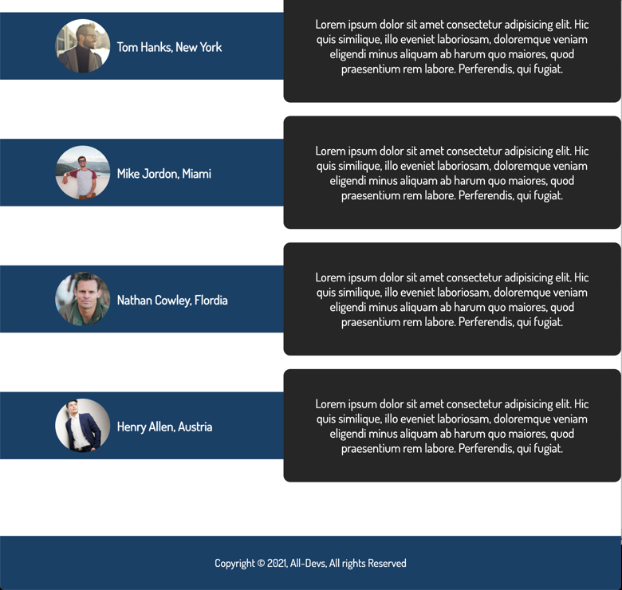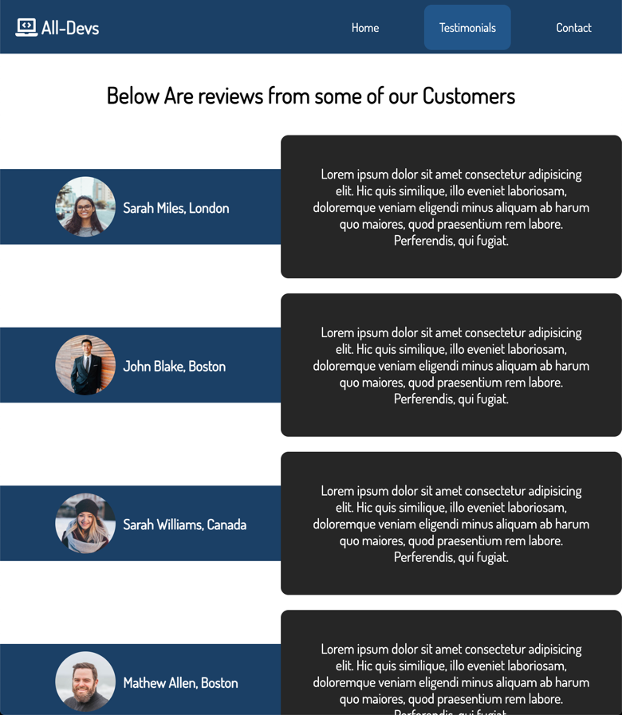The testimonials page has a collection of reviews from different people that have used the services of this company. It consists of the review its self, a picture of the reviewer and their name. A screenshot of the testimonials page is as follows (These are two different screenshots combined together):

Contact Page:

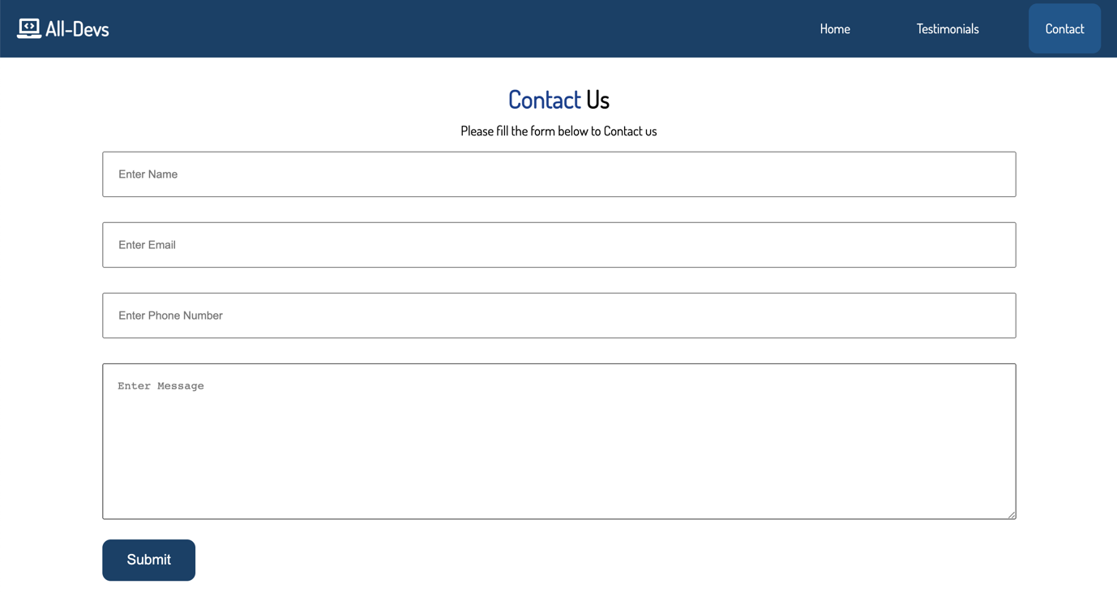In the beginning the contact page has a form with a name field, email field, phone number field, and a message field and a submit button in the end. A screenshot of that is as follows:

After the form the contact page has an info section. This section contains the address, phone number and email of the company and after that section it has the footer. The screenshot is as follows:

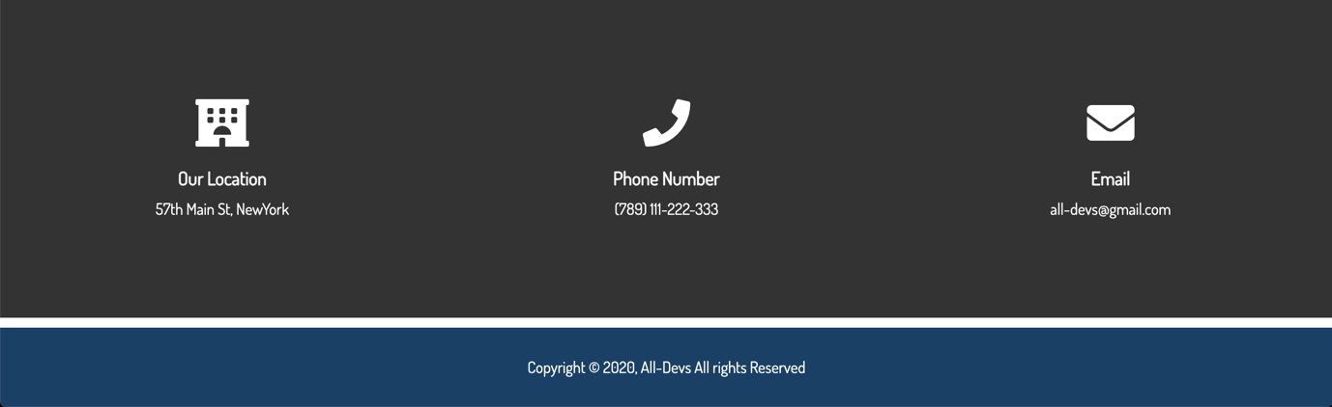

Mobile Version:

This website also has a mobile version. All of the pages change into their mobile versions once the size of the window decreases to 540 Pixels.

Home Page (Mobile Version):

This is how the home page would look in its mobile version:

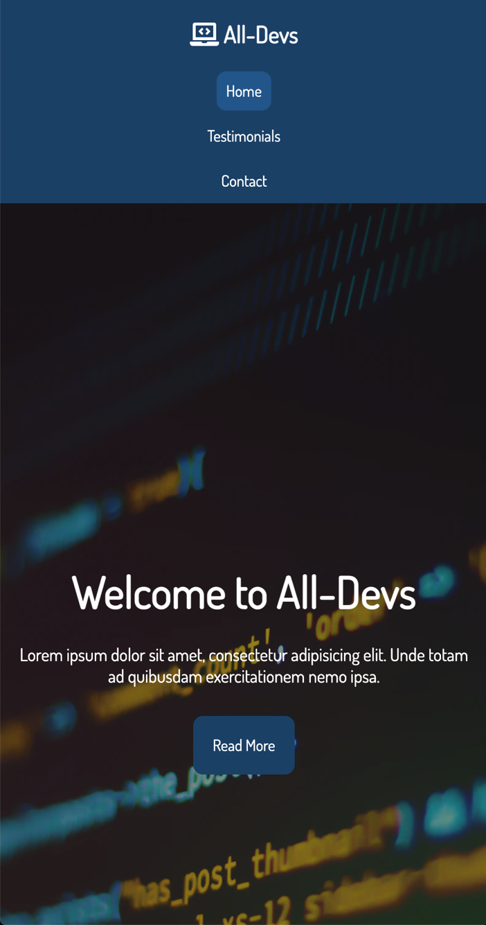

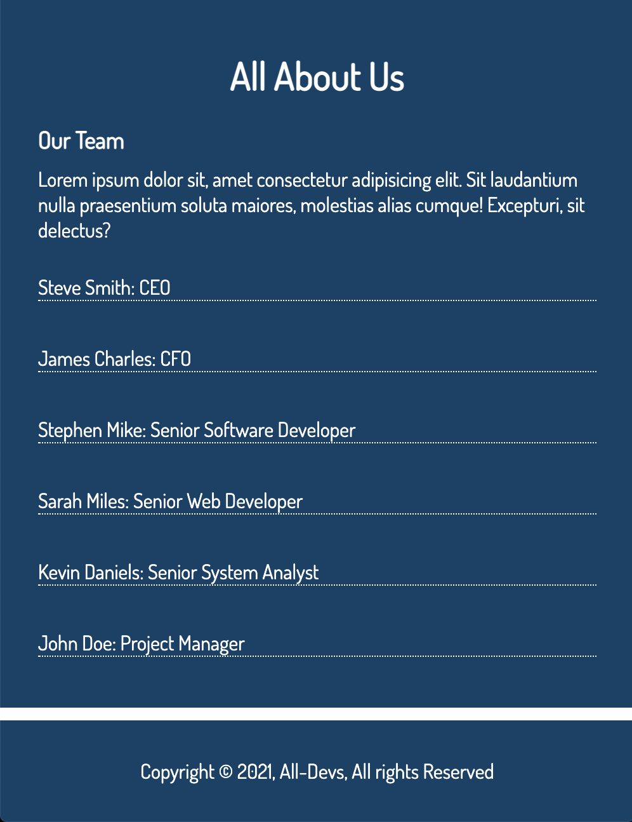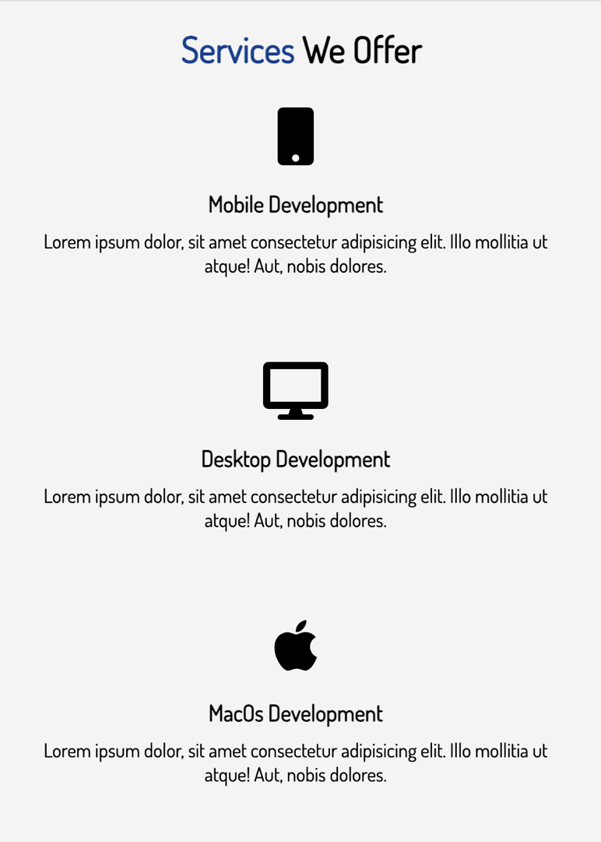

Testimonials Page (Mobile Version):

This is how the testimonials page would look in its mobile version:

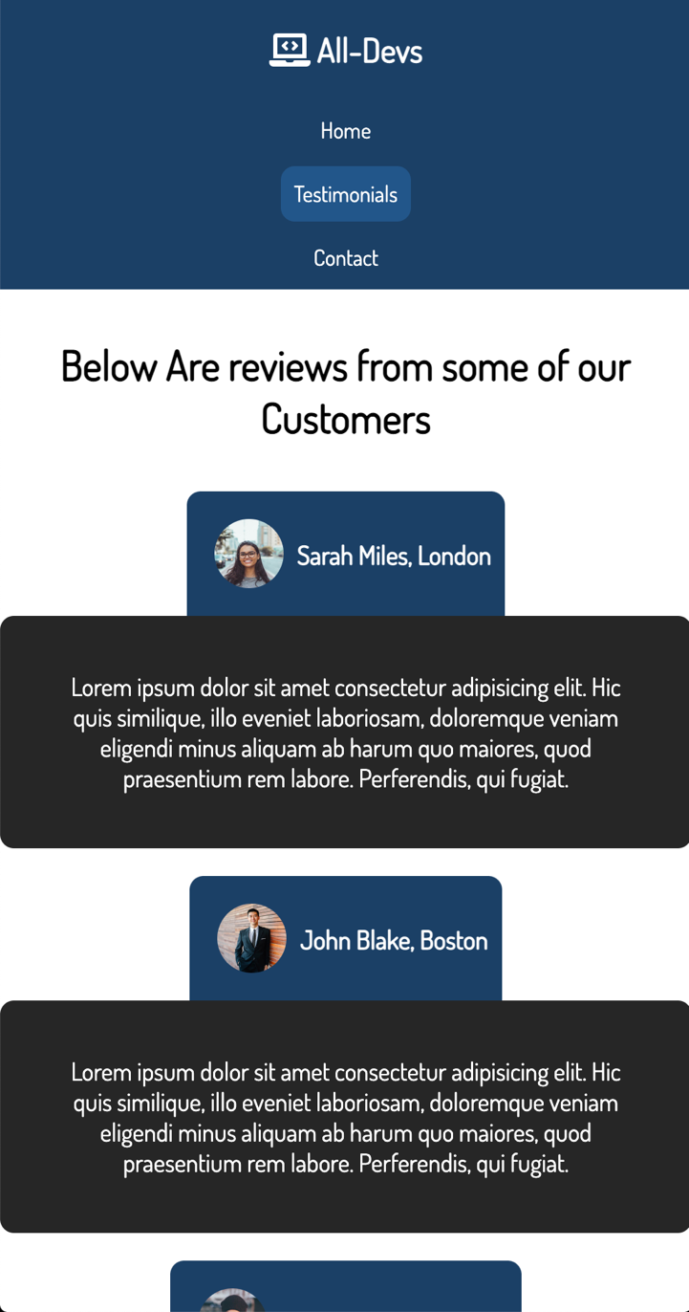

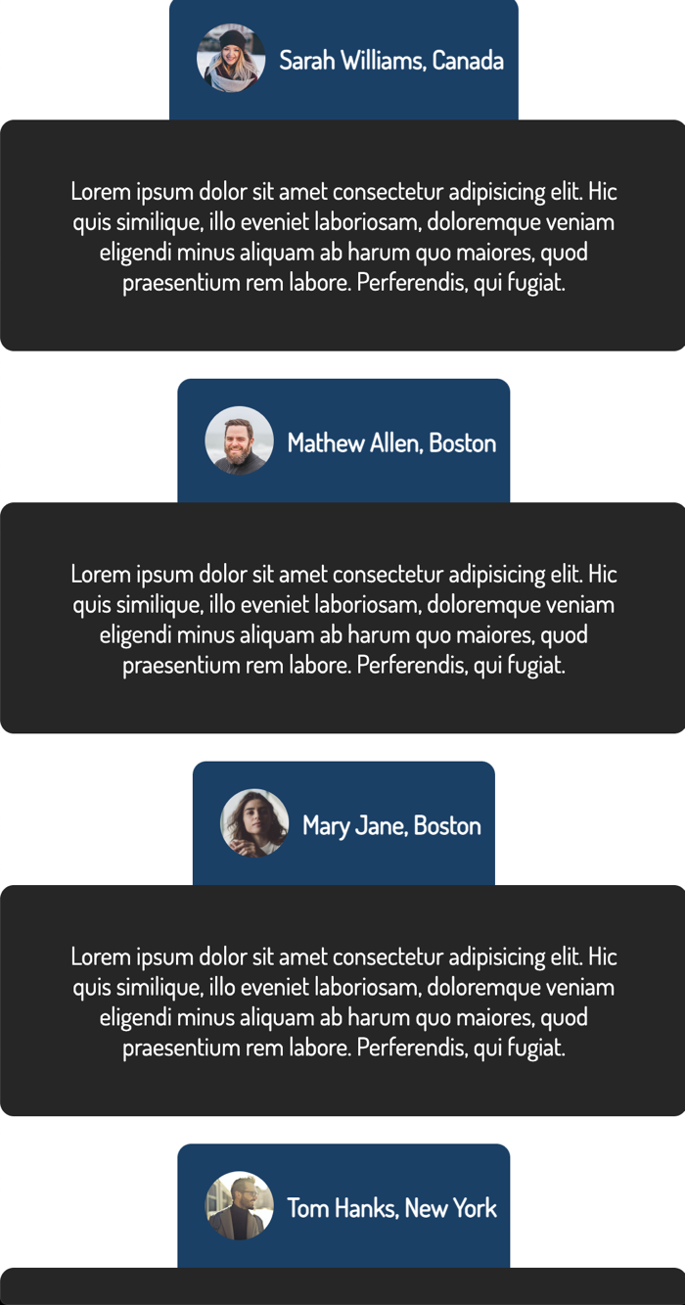

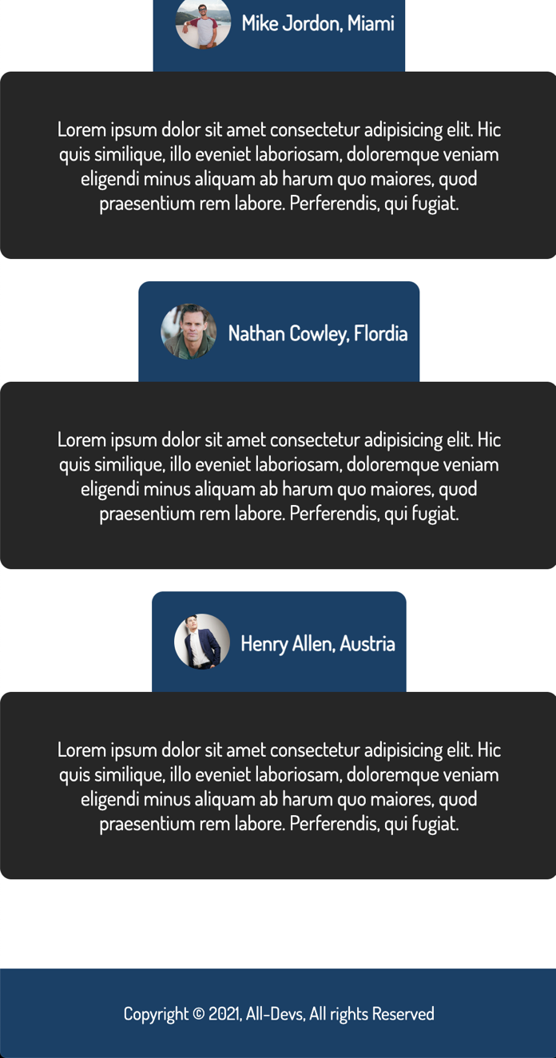

Contact Page (Mobile Version):

This is how the contact page would look in its mobile version:

